Practical No. 1
Aim : Amplitude Shift Keying (ASK) using any simulator

Name : Danish Altaf Solkar | Class : CO - B
Enrolment no. : 24111590805 | Batch : 2

Code :-
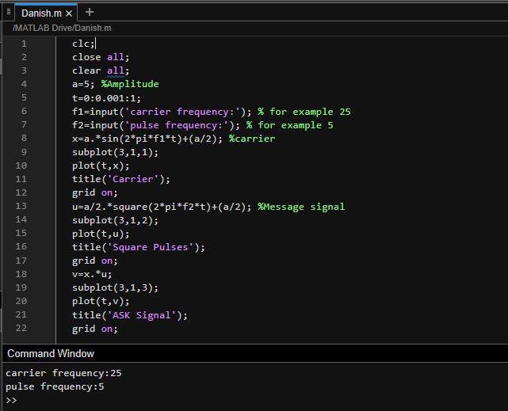

OUTPUT :-
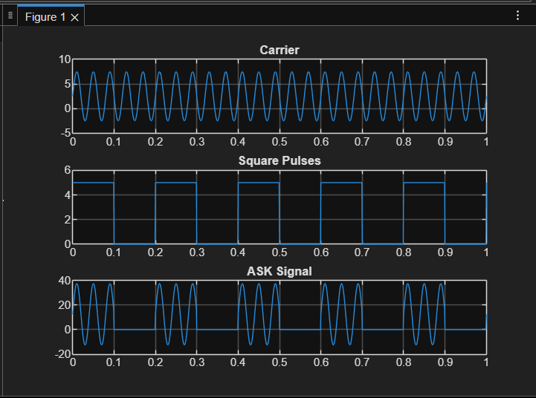

Process related  (15) | Product related  (10) | Total Marks  (25) | Signature

